TITLE: YOCLE

YOCLE (Your Out-of-Classroom Learning Experience) is an education-oriented platform dedicated towards supporting the development, assessment and providing evidence of student learning in their holistic competencies and generic skills. It can be used within classroom settings but is particularly useful for recording out-of-classroom learning experiences such as extracurricular activities. Students, skill assessors, and activity coordinators can set up an account on YOCLE and view the profiles of others. Through participating in activities, students have the chance to practise and enhance their generic skills. Students can keep track of their progress of skill acquirement on YOCLE and learn more about themselves in the process.

After an activity takes place, assessors may leave participants comments and a rating on YOCLE for each of the competencies related to the activity. Ultimately, the ratings amount to an average score for each competency and an overall generic score for each student.

We strive to make YOCLE a student-focused application that can be used to assess students' holistic competencies in a fair and standardised manner. We envision YOCLE to be an accessible, reliable, and useful platform for both students, teachers and coordinators from outside classroom settings that is also fun to use.

YOCLE (a great tool to help students to be responsible in their learning)

* Create activity for teachers or activity coordinators such as scout leader etc
* Assess students using different methods for their competencies
* Rate students on the different competencies
* Connect to peers, teachers or coordinators in a fun, engaging and intrusive way
* Messenger capability
* Based on research findings and framework
* Student-centred tool that uses social networking theories for the young generation today

IMAGES:

1. Logo and Login image

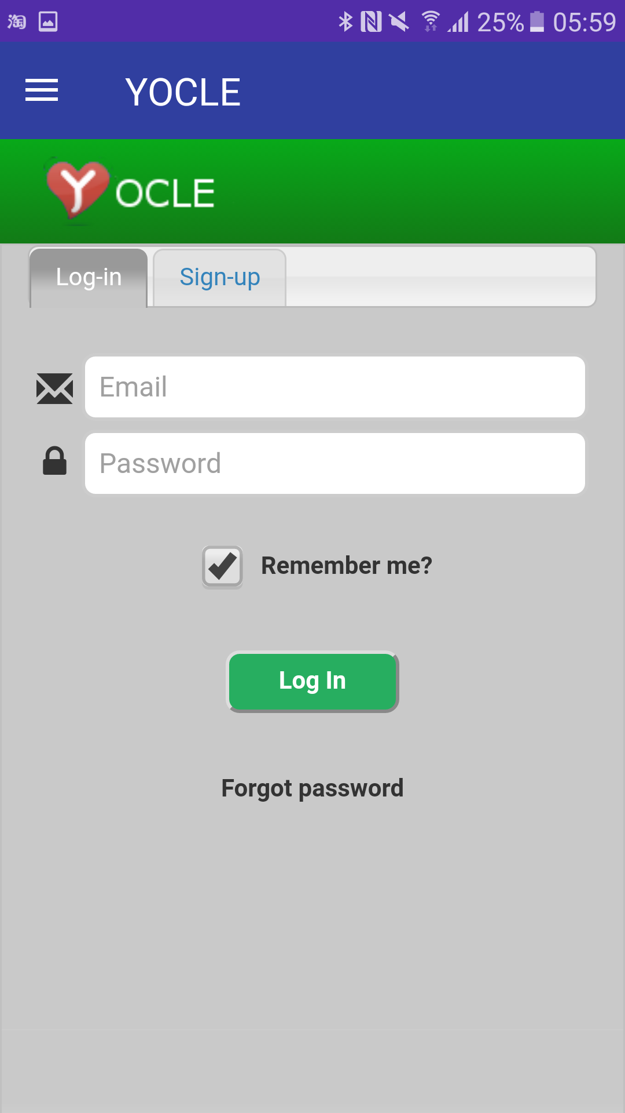

1. Profile image

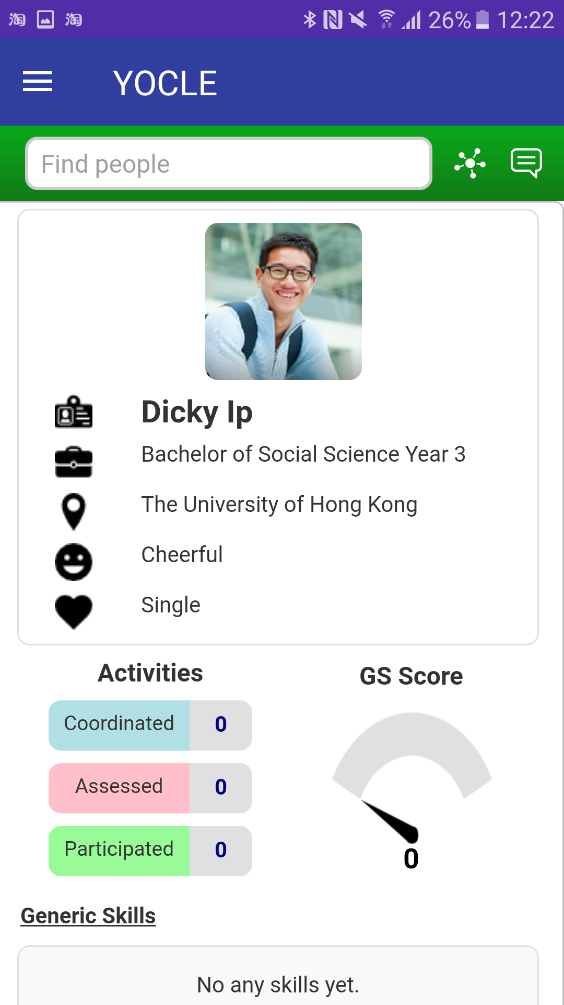

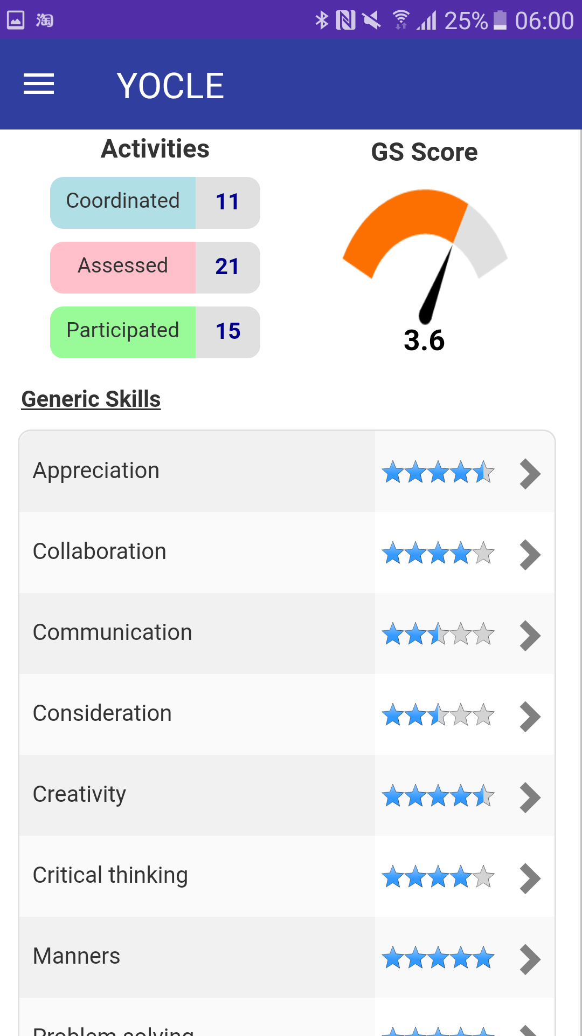

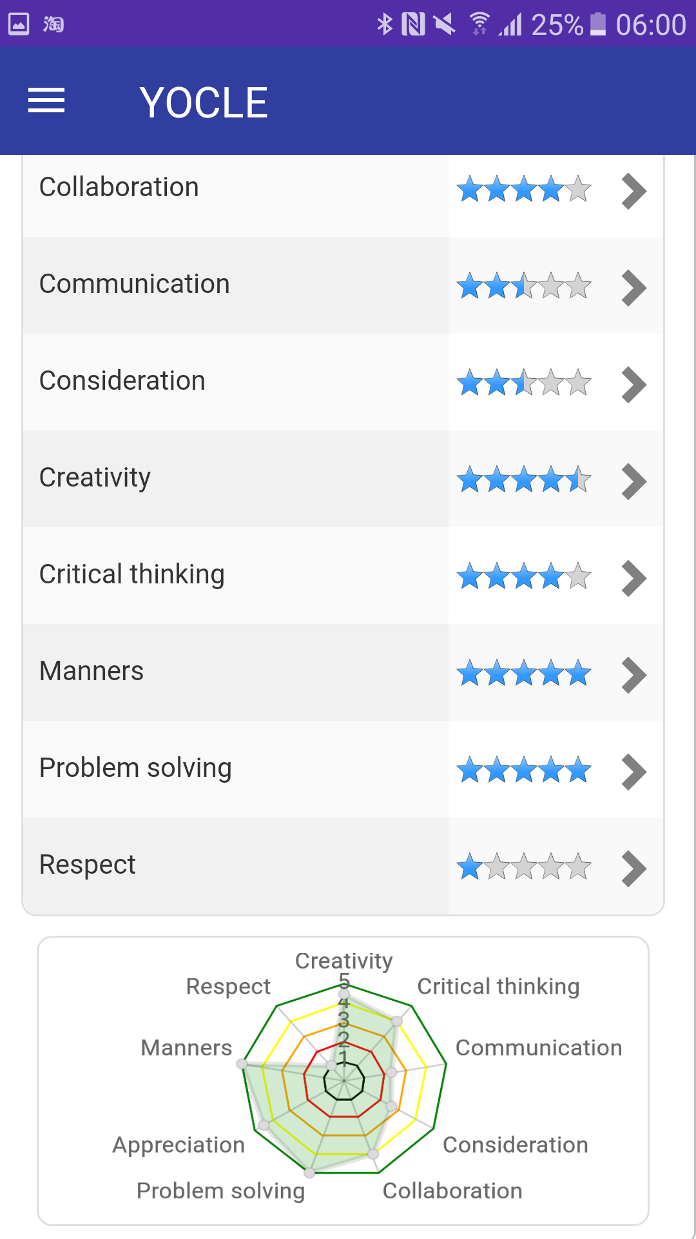

1. Whatsup image

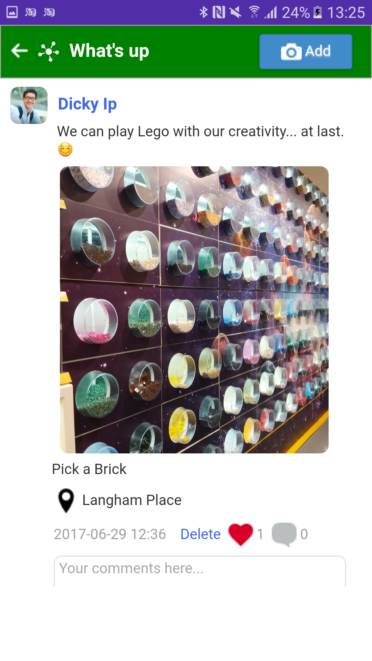

1. Peers image

